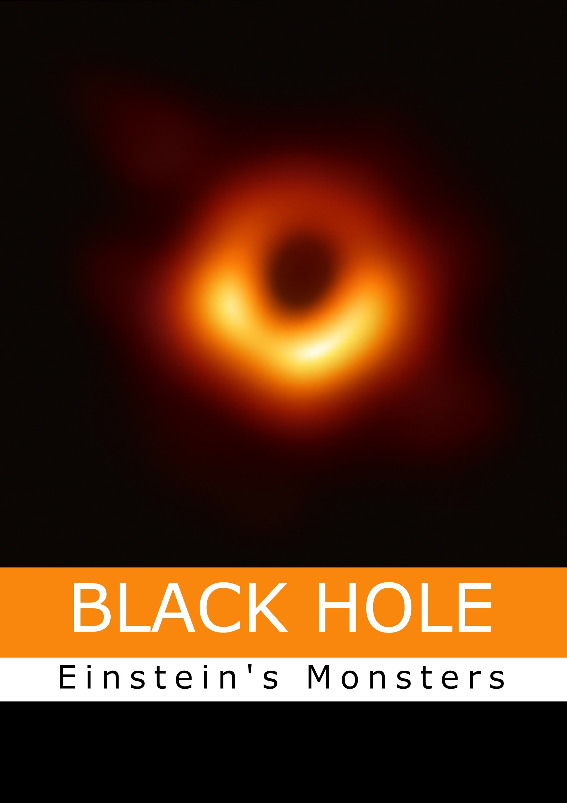

**Group Members**

**Hafeez Ghanchi**

**Role**: Research Work

**Khuzaima Aziz**

**Role**: Content Writing

**Abdullah Nadeem**

**Role**:Programming

**Asad Sheikh**

**Role**: Model

**Index**

**1.Black Hole In a Nutshell.**

**2.Man who Introduced the Concept Of Black Hole.**

**3.Understanding Space-Time.**

**4.Singularity and Schwarzschild radius**

**5.Newtonian Law of Gravity.**

**6.Behaviour of Einstein towards the idea of Singularity**

**7.Role of Stephen Hawking.**

**Black Hole In a Nutshell**

In pursuit of knowledge **contradiction** plays an important role. One famous contradiction was when Albert Einstein wondered that what if he held a mirror in front of him and then travel with the speed of light will the image disappear from the mirror?

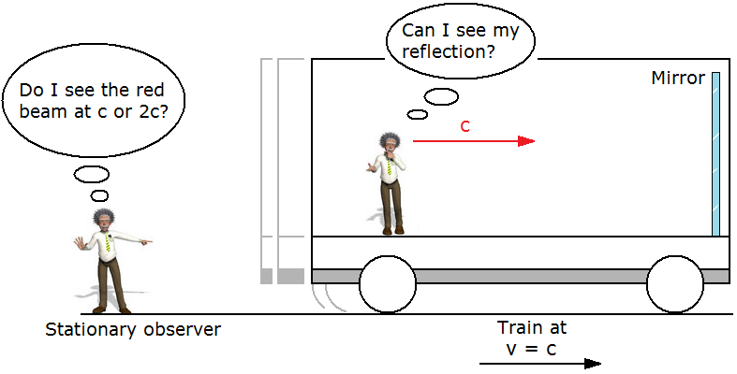

**Fig 1:** Einstein’s experiment about if someone holds the mirror upfront and travel with the speed of light will the image disappear in the mirror. Credits : [Crimson Academies Dux College](https://dc.edu.au/hsc-physics-space/)- Theory of General relativity.

Einstein used Maxwell theory and got one answer and used Newton's theory and got another one. So there was a contradiction between the laws of physics.When Einstein resolved this contradiction he concluded that **NOTHING CAN TRAVEL FASTER THAN THE SPEED OF LIGHT** and changed our views about the universe by giving the theory of space & time.So what is space time? In physics space time is any mathematical model that fuses 3 dimensions of space and 1 dimension of time single four dimensions.

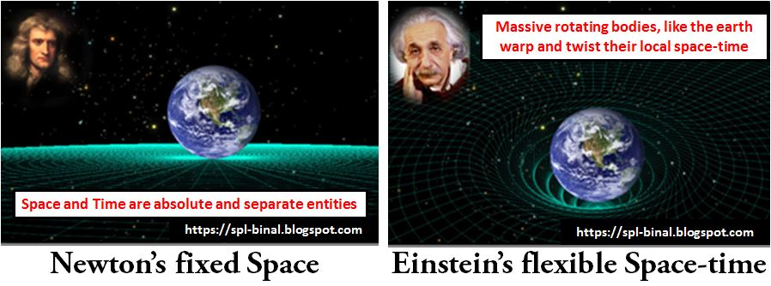

**Fig 2 :** Newton’s fixed gravity vs Einstein’s flexible space-time.Credit : [Newton Vs Einstein](https://newtonvseinstein.weebly.com/round-3-paradigm-shift.html) -Theory of relativity.

And All of these theories seeded from the **contradiction**. And then due to this contradiction different theories aroused like special theory of relativity,quantum mechanics etc which led to the advancement in physics.

The two main pillars of physics in the 20th century was Einstein's Theory of General Relativity and Quantum mechanics. Theory of Relativity states that “**Gravity is an illusion and that earth moves in a straight line in a space time curved by the sun”**.

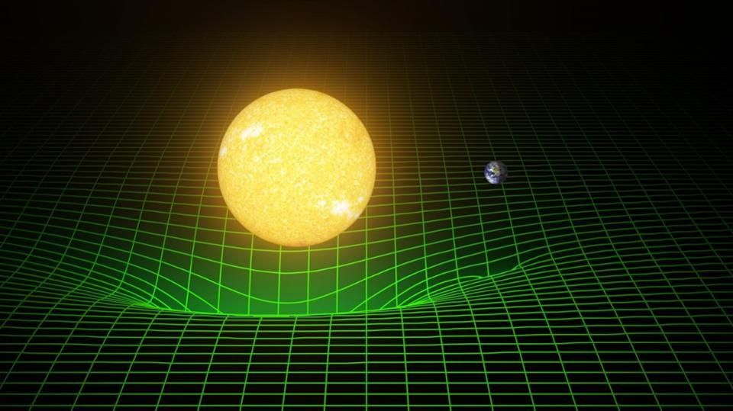

**Fig 2 :** Sun and earth warping and twisting the space-time around them according to EInstein’s Theory of relativity. Credit : [Forbes](https://www.forbes.com/sites/startswithabang/2018/06/21/einstein-wins-again-general-relativity-passes-its-first-extragalactic-test/#5ca2a632f577)-Einstein’s theory of relativity.

Now what is a black hole? As we know that escape velocity of earth is 11 km/sec while in order to escape a blackhole u need to travel faster than the speed of light and we already discussed that nothing can travel faster than the speed of light so nothing can escape a blackhole not even light.

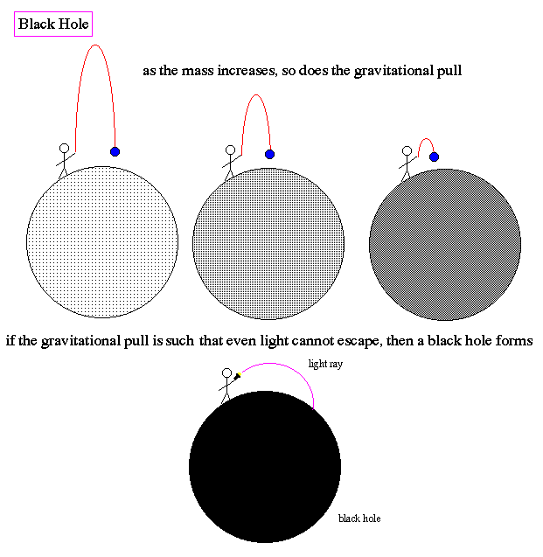

**Fig 3 :** Escape velocity of a blackhole.Credit : [Uoregon/ lec21](http://abyss.uoregon.edu/~js/ast122/lectures/lec21.html) - Escape velocity of black hole.

Schwarzchild used Einstein’s theory of relativity to further define a black hole and Singularity. But it was so confusing that even Einstein himself concluded that they don’t exist. After 60 years of research now we know the properties of a blackhole.It is the simplest object in the universe. John wheeler who invented the word “Black Hole” says “**Black Hole have no hair”**. Now Stephen Hawking came and gave a new theory about Black Hole.He said that black holes use quantum mechanics while Einstein used classical mechanics. He used uncertainty principle and concluded that black holes are not exactly black but they radiate temperature . They obey the law of thermodynamics which tells you how hot the radiation is.

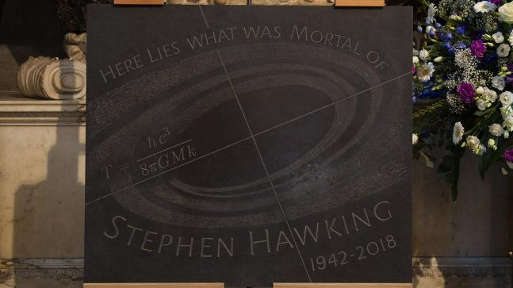

Hawking focused on a topic that most physicists preferred to avoid i.e singularity. As we know that singularity also confused Einstein and he also started doubting his own theory. In mathematics a singularity is a situation in which a function has an infinite value.In physics however Singularity is a big problem.In general theory of relativity, space-time can behave strangely. Space-time can have folds, tears, edges, holes, creases. The general theory of relativity “landscape” is different than Newton theory of Gravitation which is based on 3-dimensional space that is simple and linear everywhere. General relativity includes possibility of singularities.Hawking then turned his attention to blackholes.Along with two colleagues he proposed that, like all other objects in universe are the subjects of laws of thermodynamics. Hawking also said that the surface area of the blackhole increases. When matter falls into the black hole the area of event horizon increases. This led to a new debate with startling conclusion.In 1967 John Wheeler said that the black holes are simple objects which could be described by their mass,angular momentum and charge. He called this he “no hair” theorem,hair being the metaphor for most physical object. Jacob Bekenstein one of Wheeler's students tried to combine the wheeler’s Theory with Hawking’s understanding of blackholes. Bekenstein argued that the area of black hole is a manifestation of its entropy. The “no hair” theorem said that blackholes don’t have entropy. But Bekenstein pointed out that nothing observed in nature was immune from the 2nd law of thermodynamics i.e entropy is always increasing. Hawking accepted Bekenstein’s argument,but he was puzzled at the thought that if a blackhole has entropy it must also have temperature.If it has temperature it should also radiate energy.If nothing escapes from gravity how does it radiate. Quantum Mechanics implies that there are subatomic particles all over space i.e matter and antimatter that briefly borrowing energy from vacuum but if that happens near blackhole one of the pair will be swallowed by the event horizon leaving the other free to escape that takes its stolen energy with it and since that energy comes from blackhole so blackhole have to pay the debt and which results in slowly leaking away of its energy.

**Man who Introduced the Concept Of Black Hole:**

**John Michell (25 Dec 1724 – 29 April 1793)** was an Anglican clergyman whose scientific work spanned a wide range of subjects from astronomy to geology, optics, and gravitation. John michell studied mathematics at Cambridge University, where he taught mathematics, Greek and Hebrew later on. He found the field of seismology by recognizing that earthquakes travel as waves through earth and it earned him a place in Royal Society. John Michell was the first person in history who suggested that Black Hole could exist, not only that he also introduced the concept behind earthquakes that earthquakes are caused by the movement of the rocks miles below the earth’s surface. He also invented the torsion balance to weigh our planet.

As John suggested for the first time in the history of heavenly object massive enough to prevent light from escaping (the concept of escape velocity was well known at the time). He introduced the idea in a 1784 paper. He called that object “**DARK STAR**” (the predecessor of the modern idea of a black hole under general relativity). That object wouldn’t be visible but it could be identified by the movement of the companion star.John also derived the radius of such object i.e ”**DARK STAR”** on the basis of its mass which roughly corresponds to what is called Schwarzschild radius in general relativity.

**Pierre-Simon, marquis de Laplace:**

Pierre-Simon, marquis de Laplace, (born March 23, 1749—died March 5, 1827, Paris).French astronomer and physicist. Laplace was the son of peasant farmers . In 1766 Laplace entered the university of Caen,but he left without taking a degree. He arrived with a recommendation letter to the mathematician Jean d’alembert. He taught at École Militaire from 1769 1776. Laplace used Newton’s theory of gravitation to account the derivation of planets from their theoretical orbit.

Laplace was unaware of the work of John Michell. In his 2 volume book he mentions brief idea about a **DARK STAR** i.e Black Hole. He considers the gravity of hypothetical star much larger than Sun. In his words, “**It is therefore possible that the largest luminous bodies in the universe may, through this cause be invisible``.** A friend challenged him to prove it, which he did, but his work was flawed for the same reason as Michell.

Laplace didn’t mentioned any reference about dark star later on in his editions of books mainly because Thomas Young showed in 1799 that light behaves as a wave and it is unlikely that gravitation could slow down a wave.

**Newton's Gravity**

The earliest philosophers wondered why objects naturally tend to fall toward the ground. Many philosophers of that time gave different theories about this for example: Aristotle thought that it was the nature of rocks to seek earth.

Nicolaus Copernicus is considered the first to challenge the ptolemy’s geocentric system i.e Earth centered theory and suggested heliocentric system which means that Sun is at the center of our solar system.This theory was supported by naked eye measurements of planets by Johannes Kepler and Galileo Galilei.Kepler showed that the motion of planets is ellipse in his 3 famous laws.

Finally, inEinstein’s theory of Gravitation, we look at the theory of general relativity proposed by Albert Einstein in 1916. His theory comes from a vastly different perspective, in which gravity is a manifestation of mass warping space and time.

**Understanding Space-Time**

Albert Einstein, a 26 year old clerk dismantled the Newtonian system. In 1905 he wrote four papers that would change the face of physics.In one he looked at the photoelectric effect,where electrons are released when light shines on a material.In second he presented the most famous equation in physics: E=mc2.This says that mass and energy are equivalent and interchangeable.

In the third he laid out the special theory of relativity.The theory built on Galileo’s idea that the laws of nature should be the same for all observers moving at constant speed.He added the second premise that speed of light doesn’t depend on motion of an observer.According to him light does not obey simple arithmetic.Light speed is universal constant.As we know that speed is distance divided by time.As object travel very fast and approach the speed of light,they shrink in the direction of motion and their clocks run slower.So basically Einstein’s theory says that light is the fastest thing there is,so on this basis he predicted that objects will get more massive as they approach the speed of light,increasing their inertia so they will never be able to reach or exceed the speed of light.

Einstein extended his ideas from constant motion to accelerated motion.He began with another Galilean insight.He said that all objects fall at the same rate regardless of mass.This means that inertial mass is the same as the gravitational mass.This puzzled Galileo,but Einstein suspected that it was a key to new concept of gravity.

The equation of general relativity relate the amount of mass and energy in a region to the curvature of the space.The flat and linear space of Newton,is replaced by space that’s curved by the objects its contains.Thus space and time are linked,so gravity can distort time as well as space.

Three effects of general relativity are relevant for situations of dense matter.First is the deflection of light as it follows the undulations of space-time due to concentrations of mass.When Einstein published this theory,a team led by English astrophysics Arthur Eddington measured the slight bending of starlight as it passed near the edge of sun.It wasn’t precise measurement but the affirmation of relativity turned Einstein into celebrity.A second effect is a loss of energy as light leaves a massive object,called gravitational redshift.

General relativity seems remote from everyday life,but the GPS system would fail totally if time dilation was not included in the calculations.

**Singularity and Schwarzschild radius**

**Brief Introduction**

Schwarzschild was born in Frankfurt and he published two papers on binary star orbits when he was sixteen and then later on became professor and director of the Observatory at the University of Gottingen.When he was 40 World War 1 broke out so out of love for his country he joined the military and rose to the rank of lieutenant.

Schwarzschild correspond with Einstein in late 1915.He submitted a paper for publication in February 1916.Einstein was impressed that he significant Einstein’s theory of relativity but also he did that in the middle of  **WWI**.

**So What exactly is Schwarzschild Radius?**

Schwarzschild showed that any mass can become a black hole if it is compressed in a sufficiently small sphere with the radius Rs,and this radius is known as Schwarzschild Radius means the radius at which an object becomes a blackhole.For instance if we consider our earth so how much Scharwarzchild radius will be of our earth? We can find out just how Schwarzschild showed us that we will compress the whole mass of earth to a small sphere in case it is earth so we have to compress the whole mass of earth i.e 5.972 × 10^24 kg to a small sphere i.e a ping pong ball so the whole mass of earth will be compressed at a single point this point is called **Singularity**.So we have compressed the earth to the size of a ping pong ball given that we haven't changed its mass so now earth has become a black hole with the singularity at the center and the radius of this black whole will be called **Schwarzschild Radius**.

**What is Singularity in a Black hole?**

Singularity is one of the characteristics of a Black hole.In the center of a black hole is a gravitational singularity, a one-dimensional point which contains a huge mass in an infinitely small space, where density and gravity become infinite and space-time curves infinitely.Simply you can say that The more mass you place into a small volume of space, the stronger the gravitational pull gets. According to Einstein's general theory of relativity, there's an astrophysical limit to how dense something can get and still remain a macroscopic, three-dimensional object. Exceed that critical value, and you're destined to become a black hole: a region of space where gravity is so strong that you create an event horizon, and a region from within which nothing can escape.And in order to escape from it you need velocity equal to the speed of light and since nothing can travel faster than the speed of light so nothing can escape from the blackhole if it enters the **event horizon.**

**Then what is Event Horizon?**

In simple words you can say that Event Horizon is the boundary of a blackhole.From where u can enter but if you past the Event Horizon you won’t be able to return back from the black hole.**The event horizon is the ultimate prison wall — one can get in but never get out," Avi Loeb, chair of astronomy at Harvard University.**At the event horizon the escape velocity is equal to the speed of light and as nothing can travel faster than the speed of light Thus, nothing that enters a black hole can get out or can be observed from outside the event horizon.Likewise,any radiation generated in horizon can’t escape beyond it

**Behaviour of Einstein towards the idea of Singularity**

Einstein wasn’t pleased.Both he and Eddington were convinced that a singularity was a sign of imperfect physical understanding.It made no sense for the physical object to have a zero size and infinite mass density.Einstein’s theory had created something monstrous.Other physicists thought Schwarzschild solution was an esoteric curiosity.For a star like the Sun,the Schwarzschild radius i.e the size of the event horizon was 3 kilometers.How could a star that was 1.4 million kilometers across-over 100 times the size of the earth collapses to the size of a village?

But Another physicist Rovert Oppenheimer was convinced it was possible.He developed the tools for understanding nuclear matter.The Sun is stable and it has a constant size as long as reactions continue.When the Sun runs out of hydrogen fuel it will collapse to a white dwarf. Indian astrophysicist worked out that the gravity of stars more massive than the Sun overcome the force of pressure and collapse down to the density of a vast atomic nucleus.That’s called a neutron star.In 1939,Oppenheimer and one of his graduate students wrote a paper with a challenging calculation,they showed that an even more massive star will collapse until it reaches a density beyond any known form of matter.At the end of the massive star’s life,a black hole forms.

**Role of Stephen Hawking**

Stephen hawking was another brilliant mind who took on the challenge of of black holes.He scraped the First Class Honors degree after working no more than an hour a day for three years.Stricken by ALS,a degenerative motor neuron disease.He was given two years to live.Yet

He was elected to the Chair of Mathematics at Cambridge University.He nearly died of pneumonia in the 1980s,which resulted in him losing his speech and being given his mechanical voice.A Brief History of Time launched him as a celebrity.

Hawking focused on topic that most physicists preferred to avoid:singularities.As we’ve seen the implication of singularity at the center of black hole caused even Einstein to doubt his own theroy.In mathematics,a singularity is a situation in which function has an infinite value.In physics however,infinity is a big problem.Hawking wasn’t sure that singularities indicated a problem with general relativity.In general relativity,space-time can behave strangely.These behaviors are part of the theory.Space-time can have folds,tears,edges,holes,creases.General relativity includes the possibility of singularities.

There are only two kinds of space-time singularity in general relativity.A singularity might be caused by matter being compressed to reach infinite mass density (as in black hole).Or it might arise when light rays come from a place of infinite curvature and energy densityHawking and penrose aimed for a general treatment.They stripped away as many assumptions as possible and proved a celebrated series of singularity theorems to show that singularities are inevitable in general relativity.Basically they’re a feature not a bug.Every black hole must have a singularity.Hawking used the cosmology example for his thesis and it made him an instant rockstar.

Hawking then turned his attention to black holes.Along with two colleagues he proposed that,like all other objects in the universe,black holes are subject of thermodynamics.One of Hawking’s black hole “laws” was that the surface area of blackholes was increases.When matter falls into a blackhole the area of the event horizon grows,and when tw black holes merge the area of the resulting event horizon is bigger than the sum of the individual event horizons.This led to a new debate.

John Wheeler suggested that black holes were very simple objects,which could be described by just their mass and their angular momentum.He called this the “no hair” theorem.Jacob Bekenstein,one of Wheeler’s graduate students,attempted to combine Wheeler’s theory with Hawking’s understanding of black hole surface area.Bekenstein argued that the area of black hole was a manifestation of its entropy.The “no hair” theorem implies that black holes don’t have entropy,but Bekenstein pointed out that nothing observed in nature was immune from the 2nd law of thermodynamics i.e entropy is always increasing and blackhole should be exception .Hawking accepted Bekenstein’s argument,but he was then faced with a puzzle.If a black hole has entropy,it must also have a temperature.If it has a temperature then it must radiate energy.But if nothing escapes from black hole, how can it radiate energy?

Hawking’s answer to his stunned the theoretical physics community.He said that black holes evaporate.In classical physics,the vacuum of space is empty.But in quantum theory,”virtual particles” are constantly being created and destroyed.They exist for tiny instants of time,allowed by Heisenberg’s uncertainty principle.Normally these pairs of particle and antiparticle,or pair of photos,disappear with no effect.But close to the event horizon of a black hole,intense gravity can pull the virtual pairs apart.One falls in and the other flies away become real.This is how black hole radiates energy.The energy needed to create the particle comes from gravitational field of black hole,resulting in a decrease in mass.

Hawking radiation was controversial but undeniably brilliant,and Hawking was soon elected as Fellow of Royal Society.Unfortunately,the effects of Hawking radiation are extremely small for a star remnant mass of Sun-a mere ten-millionth of a Kelvin,far too small for an astronomical measurement.The evaporation rate is amazingly slow.It would take 1066 years for a black hole the mass of the Sun to disappear completely.

**Mass of Black Hole**

Consider a star orbiting around a black hole in an elliptical orbit . In order to find the mass of Black Hole we are going to use the given formula

**M=4π2 a3/GT2**

Where,

M=Mass of black hole.

a=semi major axis i.e a= r1 + r2/ 2.

T=Orbital period.

Now let's consider a star **So-2** which orbits around a black hole **Sagittarius A**. It take 15.6 years for the start So-2 to complete its orbit around the black hole.When the star is close to the black hole that point is called **periastron**  and when the star is farthest from the black hole it is called **apastron.**As we discussed earlier that semi-major axis is the addition of periastron and apastron divided by 2.In this condition the periastron of So-2 is equal to 120AU and apastron is equal to 1800AU.So by putting the values we can determine the semi-major axis of star So-2.

a=rperiastron + rapastron / 2

a=120+1800/2

a=960AU. Where 1AU= 1.496*1011m

Now in order to find the orbital period of the star So-2.We are going to use the following formula:

**T=2πa3/2/[G(msgr A + mso-2)]1/2**

But as the mass of **Sgr A** is fairly large compared to the star So-2,so we are going to neglect the mass of star So-2.So the formula will become

**T=2πa3/2/[G msgr A]1/2**

So the value of **T** is already given i.e 15.6 yr so we can find the mass of black hole by using the given formula,

**M=4π2 a3/GT2**

First we have to convert **T** in seconds so,

T=15.6 * 365 * 24* 60 * 60.

T=491961600secs.

Value of G is,

G=6.67*10-11

Putting the values,

M=4*(3.142)2*(960)3/ 6.67*10-11*(491961600)2.

M=7.292*1036kg

Which is the mass of Sgr A.we can use the given formula i.e

**M=4π2 a3/GT2**

To find the mass of black hole .and in order to find the orbital period we can use the formula

**T=2πa3/2/[G(msgr A + mso-2)]½**

**Orbital Velocity Of a Star**

Consider a star SO-2 that orbits around super massive blackhole Sgr A*. Now we want to determine the orbital velocity of star went it is close to the blackhole **(periastron)** i.e Sgr A* and the velocity of star when it is farthest away from the blackhole **(apastron)**.Now in order to find velocity first we are going to need the semi-major axis.Which can be found out by using the following formula.

a=rperiastron + rapastron/ 2

Where a is the semi major axis. Now the next thing needed is the mass of Sgr A*. So we have already found out the mass of Sgr A* i.e 7.3 * 1036 kg. And Universal Gravitational constant is also needed which is 6.67 * 10-11 .

Now,

**TE periastron =TEapastron (TE=Total Energy)**

**½ mSO-2(Vperiastron)2 - G mso-2 msgrA* /rperiastron = ½ mSO-2(Vapastron )2 - G mso-2 msgrA*/rapastron**

**½ (Vperiastron)2 - G msgrA*/rperiastron = ½ (Vapastron)2 - G msgrA*/rapastron** eq(1)

We knowangular momentum is

**L=mvr.**

So,

**Angular momentumperiastron  = Angular momentumapastron**

**mSO-2  Vperiastron rperiastron = mSO-2  Vperiastron rperiastro Vperiastron rperiastro**

**Vperiastron rperiastro =Vperiastron rperiastro**

By solving the above equation and putting it in eq(1) we have,

**Vperiastron={ 2Gmsgr A* rapastron / rapastron rperiastron + (rperiastron)2}½**

**Vperiastron=(Gmsgr A*rapastron / a rperiastron)**

We know a is equal to semi major axis and also the value of rperiastron is 120 AU and value of rapastron is 1800 AU.So by putting the values and solving it we will get the velocity.

**Vperiastron = 7.1 * 106 m/s**

By substituting the value in momentum equation we can find the value of apastron,

**Vapastron= 4.5 * 105 m/s**

**Schwarzschild Radius**

The Schwarzschild radius (sometimes historically referred to as the gravitational radius) is a physical parameter that shows up in the Schwarzschild solution to einstein;s field equation, corresponding to the radius defining the event horizon of a Schwarzschild blackhole.

Now to derive the Schwarzschild Radius,

**K.E=P.E**

**½ mve2= Gm/R**

If we solve this equation we will get the escape velocity,

**Ve=(2G/R)½**

Which is the expression for escape velocity.

Now using this expression,

**Ve=(2G/R)½**

Take Ve = C (speed of light) because we want to find the schwarzschild radius and the velocity is equal to the speed of light in schwarzschild radius.

**C2=2G/Rs where Rs = Schwarzschild radius.**

If we solve this expression we will get

**Rs = 2G/C2**

We can use this expression to find the Schwarzchild radius of any object.

**Schwarzschild metric:**

In Einstein's theory of general relativity, the Schwarzschild metric is the solution to the Einstein field equations that describes the gravitational field outside a spherical mass, on the assumption that the electric charge of the mass, angular momentum of the mass, and universal cosmological constant are all zero.

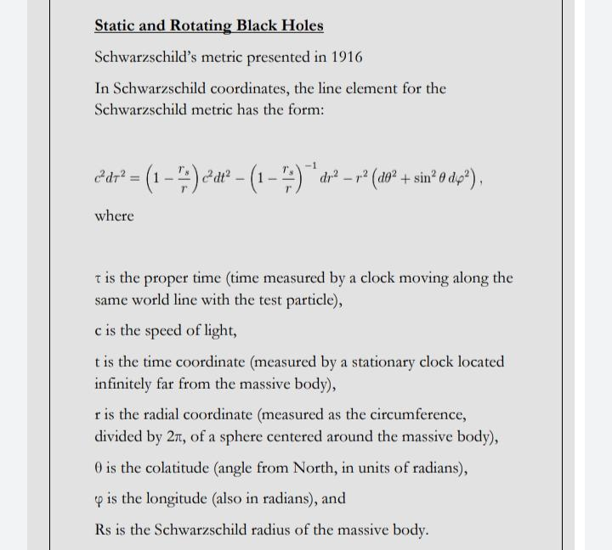

From the above equation it is clear that if the radial coordinate is equal to the schwarzschild radius then space time become will become undefined. That's why laws of physics breaks inside a black hole.

**Reference**

**Books:**

* **Einstein’s Monsters by Chris Impey**

<https://www.amazon.com/gp/offer-listing/1324000937/ref=tmm_hrd_used_olp_0?ie=UTF8&condition=used&qid=&sr=>

* **Black Hole Math - NASA**

<https://www.nasa.gov/sites/default/files/atoms/files/black_hole_math.pdf>

**Videos:**

* Playlist:

<https://www.youtube.com/playlist?list=PLVRtZekycSGoajELOqzB5ptmh2fwx_uce>

**Courses:**

* What are Black Holes: <http://www.worldscienceu.com/science_unplugged/videos/what-are-black-holes>
* Astro 101: What are black Holes:

<https://www.coursera.org/learn/black-holes-astro-101>